Epsom & Ewell F.C.
4
v
Spelthorne Sports
Saturday, 9th September 2017 – 3.00 p.m.
Good afternoon and welcome to High Road for today’s League match. We welcome the players, supporters and officials of Spelthorne Sports and wish them a safe journey home.

We defeated our opponents here by three goals to two in January, although required a late equaliser to secure a 2-2 draw there in February. Of course, 2016/17 seems a long time ago and with few players remaining from the last campaign, we have faced a very difficult start to our Centenary season.

Additionally, our opponents have started well and defeated Sutton Common Rovers 4-1 last Saturday. Make no mistake, this will be a tough match today, but then when you are at the foot of the table all matches look tough. We just have to find a way to progress from our current position.

Obviously last week’s heavy defeat to Redhill was another tough pill to swallow and we were never in the match, conceding yet again inside the opening two minutes and finding ourselves 5-0 down after just 33 minutes. Fortunately, this was all we would concede as it turned out, but it was still another dent to our goal difference.

Congratulations go to our Manager Glyn Mandeville, who marks 150 games in charge today. Whilst the start to the season is not what he or any of us will have wished for, he has an excellent record as Manager of our club and we hope he is able to turn things around quickly.

Our next home game is on Tuesday when Horley Town visit and we then make the journey to Farnham Town on Saturday before we return here for the visit of Hanworth Villa two weeks today.

Please note that it is even more important than usual that we are able to obtain sponsorship. Please give consideration to helping Epsom & Ewell FC by sponsoring a match and match ball. The cost is £55 but this does include free entry for three people, including programmes and hospitality, so why not help the club?

Enjoy the game.

Rich

Don’t forget, you can follow us on Facebook: www.facebook.com/epsomandewellfc
Twitter: @EEFCOfficial Instagram at: www.instagram.com/epsomandewellfc
and Youtube at: www.youtube.com/channel/UCtLrpS0x5OaYUACRT34_zng

Cover photos by Gemma Jarman

- Joe Loftus-Cheek brings us level at home to Chertsey Town on Tuesday 15th August

- Kyle Hough scores our second goal at Colliers Wood on Friday 25th August

Cherry Red Records Combined Counties League
Premier Division Table 2017/18
inc Wednesday 6th Sept | P | W | D | L | F | A | Pts | GD | H | A
Westfield | 6 | 5 | 1 | 0 | 25 | 3 | 16 | +22 | 14/4 | 9/12
Bedfont Sports | 6 | 5 | 1 | 0 | 18 | 8 | 16 | +10 | 24/3 | 4/11
Spelthorne Sports | 6 | 4 | 0 | 2 | 15 | 12 | 12 | +3 | 9/9 | 27/1
Colliers Wood United | 6 | 3 | 2 | 1 | 13 | 6 | 11 | +7 | 30/3 | 2-5
Walton & Hersham | 5 | 3 | 1 | 1 | 7 | 5 | 10 | +2 | 30/12 | 21/4
Abbey Rangers | 6 | 3 | 1 | 2 | 9 | 11 | 10 | -2 | 16/12 | 17/2
Guildford City | 4 | 3 | 0 | 1 | 5 | 2 | 9 | +3 | 2/12 | 7/4
Hanworth Villa | 6 | 2 | 3 | 1 | 11 | 8 | 9 | +3 | 23/9 | 10/2
Horley Town | 6 | 3 | 0 | 3 | 9 | 10 | 9 | -1 | 12/9 | 23/12
Camberley Town | 5 | 2 | 2 | 1 | 7 | 7 | 8 | 0 | 10/3 | 14/10
Redhill | 6 | 2 | 1 | 3 | 12 | 11 | 7 | +1 | 0-5 | 6/1
Sutton Common Rovers | 6 | 2 | 1 | 3 | 10 | 9 | 7 | +1 | 3/2 | 0-5
Chertsey Town | 7 | 2 | 1 | 4 | 12 | 13 | 7 | -1 | 2-7 | 31/10
Knaphill | 5 | 2 | 1 | 2 | 9 | 12 | 7 | -3 | 24/2 | 7/10
Balham | 6 | 2 | 1 | 3 | 8 | 13 | 7 | -5 | 20/1 | 25/11
CB Hounslow United | 6 | 1 | 2 | 3 | 10 | 12 | 5 | -2 | 13/2 | 2-4
Godalming Town | 5 | 1 | 2 | 2 | 5 | 9 | 5 | -4 | 11/11 | 13/1
Banstead Athletic | 4 | 1 | 1 | 2 | 4 | 6 | 4 | -2 | 2/4 | 1-1
AFC Hayes | 6 | 1 | 1 | 4 | 7 | 10 | 4 | -3 | 28/4 | 18/11
North Greenford United | 5 | 0 | 4 | 1 | 6 | 9 | 4 | -3 | 28/10 | 17/3
Farnham Town | 6 | 1 | 1 | 4 | 9 | 15 | 4 | -6 | 14/11 | 16/9
Epsom and Ewell | 6 | 0 | 1 | 5 | 7 | 27 | 1 | -20 | X | X
1

Lucky Day? – 9th September
Played 15 - Won 5 Drawn 3 Lost 7 - For 32 Against 27 - PPG 1.20 - Below Average
Our Club record against today’s opponent
Played 7 - Won 5 Drawn 2 Lost 0 - For 20 Against 10 - PPG 2.43 - Fantastic
includes one loss on penalties
Our Largest wins and losses against today’s opponent
17th September 2015 Won 6-2 - Combined Counties League (A)
Their Last Visit
7th January 2017 - Won 3-2 - Combined Counties League

Results and Fixtures so far
Emirates F.A. Cup – First Qualifying Round – Saturday 2nd September
Banstead Athletic | 0-4 | Glebe
Guildford City | 1-3 | Knaphill
Hereford | 8-0 | Godalming Town
Combined Counties League – Saturday 2nd September
Abbey Rangers | 2-1 | AFC Hayes
Balham | 2-4 | Bedfont Sports
Farnham Town | 2-3 | Chertsey Town
Epsom & Ewell | 0-5 | Redhill
Horley Town | 2-1 | Hanworth Villa
Spelthorne Sports | 4-1 | Sutton Common Rovers
Westfield | 2-2 | North Greenford United
Combined Counties League – Tuesday 5th September
Banstead Athletic | 1-0 | CB Hounslow United
Chertsey Town | 0-0 | Camberley Town
Combined Counties League – Wednesday 6th September
Colliers Wood United | 1-0 | Guildford City
F.A. Vase – First Qualifying Round – Saturday 9th September
AFC Hayes | V | Hatfield Town
Ascot United | V | Farnham Town
Banstead Athletic | V | Fisher
Bedfont Sports | V | Three Bridges
Canterbury City | V | Sutton Common Rovers
CB Hounslow United | V | Peacehaven & Telscombe
Colliers Wood United | V | K Sports
Guildford City | V | Lymington Town
Hailsham Town | V | Abbey Rangers
Knaphill | V | Sidlesham
Mile Oak | V | Chertsey Town
North Greenford United | V | Harpenden Town
Redhill | V | Chatham Town
Walton & Hersham | V | Little Common
Worthing United | V | Horley Town
Combined Counties League – Saturday 9th September
Epsom & Ewell | V | Spelthorne Sports
Hanworth Villa | V | Camberley Town
Westfield | V | Godalming Town
F.A. Vase – First Qualifying Round – Sunday 10th September
Ascot United | V | Farnham Town
Combined Counties League – Tuesday 12th September
Epsom & Ewell | V | Horley Town
Godalming Town | V | Colliers Wood United
Hanworth Villa | V | Westfield
Knaphill | V | Walton & Hersham
North Greenford United | V | Spelthorne Sports
Redhill | V | Guildford City

From behind the goal
Epsom & Ewell 0-5 Redhill
Combined Counties League - Premier Division - Saturday 2nd September 2017

Brave new dawn crushed by Lobsters

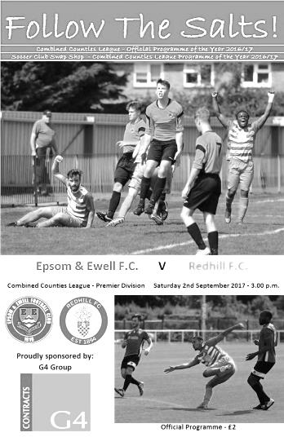
It took five League games for us to register our first point of the season at Banstead Athletic but took Redhill just 63 seconds to sweep away any pre-match optimism there might have been, and by the end of the match we were back to square one again.

Despite getting that draw just five days ago a number of players were unavailable yet again, which is severely hindering our hopes of building any stability. At the back Colin Harris had a new back line in front of him again, although Ben Dyson, Reisse Griffin and Scott Murphy were still there, joined by new signing David Thomson. In midfield it was a pleasant surprise to see Bentley Graham in Epsom colours again and he joined forces with Ben Hayward and Captain Sam Robinson. With Jason Nwachukwu and the recently signed Sean White on the flanks this left Dale Marvell to take up a position that he hadn't done for us in probably fifteen years; that of centre-forward, due to the absence of our twin striking threat of Joe Loftus-Cheek and Kyle Hough.

On paper it looked a half decent team, even allowing for the absence of our front two. Regrettably though any plans we may have had received a severe jolt in the opening moments. This was our third home game of the season, yet we have been unable to reach the two minute mark without conceding and so it proved again as two Redhill players strolled straight through the middle of our defence and Gary Abisogun fed Martin Smith who opened the scoring with a low shot past Harris.

The game was just five minutes old when they planted a header against the foot of our post from a deep left wing cross but in the 8th minute they had extended the lead as Dyson found himself with two players to deal with and the ball was threaded through to Mohamed Diakite who gave Harris no chance.

We responded with a curling twenty yard effort from Robinson that was only just beyond the far top corner of the Redhill net, but with the clock showing the 16th minute Kery Kedze executed a smart one-two and easily finished off to make it 3-0. Yet still the agony wasn't over and just five minutes later Griffin conceded a penalty. People on the sideline said that the ball had gone out of play in the build-up but Kedze placed his spot kick right up into the top right corner of Harris' goal to make it four-nil.

To this point we had created little, although Hayward had made a good run to the edge of the box where it was crudely ended by a blatant trip that earned the Redhill Captain Jonathan Trotter a yellow card, but Graham sent the free kick way over the bar from the

edge of the area. A good crossfield ball followed but White chose to volley from well out when maybe he could have chosen to keep the ball and his strike was well wide of the goal. Nwachukwu then saw his shot blocked but on the break the ball was sent in from the left for Abisogun to score the fifth goal easily in the 33rd minute.

If someone had said at that point that we wouldn't see any more goals, they'd have been laughed at. However, the visitors began to waste chances, while at our end Marvell received a good pass in from White but he dragged his shot wide and then Graham's long range try was like Robinson's earlier effort; just beyond the joint of post and bar.

This was a very depressing state first half and it threatened to get worse almost immediately after the restart as Dyson cleared a low shot off the line with Harris beaten before the visitors earned a second penalty for a clumsy challenge in the 52nd minute. Fortunately Kedze, maybe eyeing a hat trick that would have been the fourth scored against us in just six matches, sent the ball well over the bar. Harris was in action again soon after, having to make a last minute challenge with his feet.

But it must be reported that we did start to create some chances of our own from this point from that point. Nwachukwu really should have given Rhys Hughes no chance when he connected from eight yards, following a defensive slice of a left wing cross, but the shot was saved and moments later a good White delivery was met by an unmarked Marvell, but he was at full stretch and couldn't direct the volley on target.

White was maybe unfortunate to be taken off shortly after but the two substitutes that came on for him and Nwachukwu did extremely well. Louis O'Brien and Liam Roberts arrived just before the hour and were largely involved in everything positive that occurred for the remainder of the afternoon. Harris still had to make a fine save from a low shot from a left wing delivery and had to do much the same when the visitors attacked on the right wing too, but at the other end O'Brien was inches wide with a shot into the side netting after a good run before another good run set up fellow sub Roberts but he was crowded out.

Tayo Ajayi replaced the tiring Marvell and in the 82nd minute Roberts did really well to keep a run going into the box where he was then brought down, but Robinson will not remember his birthday with much affection as his penalty was saved by Hughes diving to his right. Then O'Brien tried his luck from just over 20 yards only to see the ball crash down and away off the crossbar. Ajayi following up was unable to prod the ball into the net and Hughes recovered to palm it away but as the ball then came back in Robinson got too much on his header which went over the bar. An injury time free kick from Graham into the arms of Hughes was the last opportunity of the match.

It would be easy to say there was an improvement in the second half, but it is difficult to judge how much there was when your opposition are already well clear. Did we actually improve or did they take their foot off the gas? The only way we will ever be able to find out the answer is to stop conceding goals in clusters in the first place. With Spelthorne Sports and Horley Town coming up as our next two opponents at High Road we need to give them both a proper game or else we could be in serious trouble this season. If we aren't already!

Epsom and Ewell: Colin Harris, Reisse Griffin, Ben Dyson, David Thomson, Scott Murphy,
Jason Nwachukwu, Ben Hayward, Bentley Graham, Dale Marvell, Sam Robinson ©, Sean White

Subs: Louis O'Brien for Nwachukwu (58), Liam Roberts for White (58), Tayo Ajayi for Marvell (81)

#
Club Records - 9th September
Date | Day | Competition |  | Opponents |  | Scorers
09/09/33 | Sat | London League | H | Bostall Heath | 6-2 | L.Marlow (2), J.Jones (2), L.Graves, W.Williamson
09/09/36 | Wed | London League | H | P.O.Engineers | 4-2 | G.Collins (2), B.Randall, T.Dunne
09/09/50 | Sat | Corinthian Memorial Shield 1 | H | Edgware Town | 5-2 | S.Faggetter (3), F.Boatwright, P.Jordan
09/09/58 | Tue | Southern Combination Cup 1 | H | Uxbridge | 3-0 | D.Hermitage, B.Smith, o.g.
09/09/61 | Sat | F.A. Cup 1q | H | Dulwich Hamlet | 1-2 | D.Mead
09/09/67 | Sat | Athenian League 2 | H | Aveley | 1-5 | J.Eales
09/09/72 | Sat | Athenian League 2 | H | Harrow Borough | 0-1
09/09/78 | Sat | F.A. Trophy Preliminary Round | H | Hounslow | 1-1 | A.Hill
09/09/89 | Sat | Isthmian League 2s | A | Maidenhead United | 0-1
09/09/95 | Sat | Isthmian League 3 | H | Harlow Town | 2-2 | G.Morris (pen), A.Boxall
09/09/96 | Mon | Isthmian League Cup 1 | A | Chesham United | 3-3+ | P.Meredith, M.Owen, K.Webb
09/09/00 | Sat | Isthmian League 3 | A | Clapton | 4-0 | B.Forey (3), J.Hall
09/09/03 | Tue | Isthmian League 1s | H | Bracknell Town | 0-2
09/09/06 | Sat | Combined Counties  League Cup 2 | A | CB Hounslow United | 1-2 | D.Marvell
09/09/08 | Tue | Combined Counties  League Cup 1 | H | Dorking | 1-2 | C.Heuston
Historical Decades
Date | Day | Competition |  | Opponents |  | Scorers
90 years ago – Epsom Town F.C.
10/09/27 | Sat | London League | A | Chelmsford | 1-1 | F.Watts
80 years ago – Epsom F.C.
11/09/37 | Sat | London League | H | Bostall Heath | 5-1 | B.Beglan (2), A.Griffiths, G.Collins, H.Pullen
70 years ago – Epsom F.C.
06/09/47 | Sat | London League | H | P.O.Telecoms | 3-0 | W.Webber (2), F.Chitty
60 years ago – Epsom F.C.
07/09/57 | Sat | F.A. Cup Preliminary Round | A | Bromley | 2-4 | J Rowe, J.Bangs
50 years ago – Epsom & Ewell F.C.
09/09/67 | Sat | Athenian League 2 | H | Aveley | 1-5 | J.Eales
40 years ago – Epsom & Ewell F.C.
10/09/77 | Sat | London Senior Cup 1q | H | Thames Polytechnic | 1-0 | T.Tuite
30 years ago – Epsom & Ewell F.C.
05/09/87 | Sat | Isthmian League 2s | A | Yeading | 1-3 | B.Perkins
20 years ago – Epsom & Ewell F.C.
07/09/97 | Sun | Isthmian League 3 | A | Aveley | 2-1 | A.Boxall, K.Webb
10 years ago – Epsom & Ewell F.C.
08/09/07 | Sat | Combined Counties  Premier Division | A | Egham Town | 1-1 | R.Burns

History Corner – 9th September
90 years ago this week we made another long trek to Chelmsford’s New Writtle Street Ground for a London League match with mixed results, drawing 1-1. Fred Watts scored a second half equaliser and would score two even more important goals in the final match of 1927/28, but more about that later in the season.

67 years ago today Player / Coach Sid Faggetter, formerly of Redhill before the war and a few more clubs after it, scored a hat trick for us in our 5-2 League Cup (Memorial Shield) win over Edgware Town. His good friend Freddie Boatwright also found the net that day along with Pat Jordan.

70 years ago this week we hosted the Post Office Telecoms team in a London League match and defeated them 3-0 at West Street. (see programme pictured) They had recently changed their name from the more familiar Post Office Engineers but times were hard at their Plough Lane ground in Wallington having just suffered a fire and the club never really recovered, finishing bottom that season. In fact, at the end of the season, a number of their players joined us, strengthening our team to the extent that we were able to apply for Corinthian League membership in 1949.

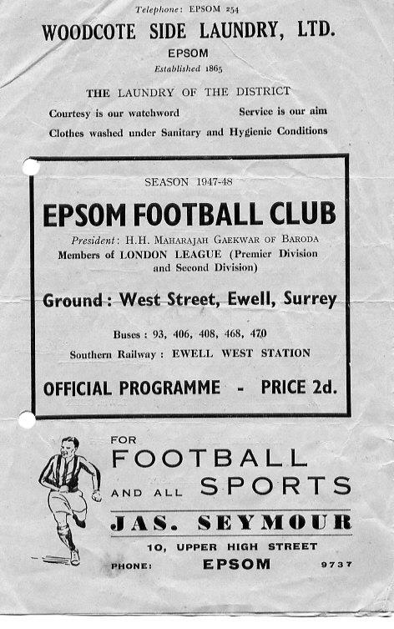
30 years ago this week we were the first visitors to Yeading’s Beaconsfield Road ground for their first ever Isthmian league match, narrowly being defeated 3-1 there. It would take a couple of years before they became a real force, earning promotion in 1989/90. Oh, and they won the F.A. Vase too that season. Ironically, we would win there that season!

21 years ago today we were a Division Three club in the Isthmian League. Still, Paul Meredith, Micky Owen and Kevin Webb all scored as we recorded a superb 3-3 draw at the Meadow after extra time to secure a replay against a team that were in the Premier Division at the time! However, we were squeezed out of the replay 2-1 at Merland Rise.

20 years ago this week we visited Aveley on a Sunday morning for a League match. The contest had been moved back a day to avoid the Funeral of Princess Diana and we didn’t fancy our chances much as we trailed in the third minute to a team that had just beaten us 3-0 at Mill Road a week previously in the League Cup. However, a fantastic clipped equaliser from a narrow angle from Andy Boxall put us level (think Eric Dier v Slovakia) and Kevin Webb scored a winner!

17 years ago today Ben Forey scored a hat trick as we defeated Clapton 4-0 on their own pitch. Perhaps the best goal was the third one scored by defender James Hall as he finished off a great move with a thumping header from close range. People ask me why I like to stand behind the goal. Goals like this are your answer and I remember it very clearly to this day!

Every Opponent A-Z
Over the years we have played many, many different opponents. Exactly how many is a difficult question, as it all depends on your definition. Are Camberley & Yorktown different to Camberley Town, or are Epsom Town different to Epsom F.C. or Epsom & Ewell F.C.?

In my analysis I have classed both of the above examples as the same team, and will work through them all from A to Z. Some we have played many times, whilst others we have met just once or twice. Enjoy!

Welling United: Played 2 - W1 D0 L1 - F3 A3 - PPG - 1.50 - Average

We know Welling United as a high flying team these days. Regular National League competitors who might drop a division from time to time, but always seem to be there or thereabouts.

We first met their forerunners Bexleyheath & Welling back in September 1956 at West Street, losing 3-1 to the professional Kent League club, but they folded in the seventies and when the lease for Park View Road came along, the newer, non-connected Welling United jumped in and remain there to this day.

They were building at the time we met in 1980 and were in the London Spartan League but with some good players, one of which, Andy Townsend, would go on to have a terrific career with Chelsea and the Republic of Ireland. They defeated us 2-1 at West Street in a London Senior Cup tie, but we gained revenge by the same score at the same venue the following season with goals from Tommy Tuite and Dave Hanks. It must be noted that we have never played at Park View Road, despite meeting its inhabitants on four occasions now, if you include the F.A. Cup tie with Erith a couple of seasons back.

As I write they are a National League South club, playing at Step Two and joined by Erith & Belvedere who now jointly own the ground in an unusual arrangement where Welling’s main stand and offices are on one side while the Deres set up home on the other side of the ground! With Erith currently in Step Six this season, you wonder whether it is an arrangement that they will be able to sustain for much longer and whether this will have a knock on effect for Welling remains to be seen.

Wellington A.F.C.: Played 1 - W1 D0 L0 - F3 A2 - PPG - 3.00 - Perfect

Although we have only met once, the trip to Wellington was one of the best football weekends of my life. A 3-2 win at Moneyfields in a match played in a hurricane had earned us a Third Round (last 64) tie in the F.A. Vase. We knew we couldn’t go very far North due to the restriction of the North / South split in the draw, but it was still kind to us and sent us out to deepest Somerset, almost on the Devon border for a clash with a Western League club.

The club made the decision to take the players down to Somerset the night before to give them the best preparation possible for the match, even though it was in doubt due to severe rain sweeping the country. Fortunately though we were able to play that day and with a strike force of Robbie Burns and Kyle Hough both hitting the target, we raced into a 2-0 lead against the strong wind. Not even we could mess this up. Could we?

We tried our hardest, conceding almost immediately but at 2-1 up and with the wind in our favour we continued to dominate until a rather fortuitous header looped over everyone and dropped under the bar for an equaliser with a few minutes remaining.

As we prepared ourselves behind the goal for the likely extra time period that followed our keeper Paul Borg made an unnecessary dash out of his goal and brought a player down in the area to give

Wellington’s main stand at the Wellington Sports Ground

them a last minute penalty, but somehow he made the save and in extra time Matt Smith was brought down in their penalty area and Hough slotted away his second penalty of the match to give us the 3-2 win.

The coach back was always going to be a happier place on the way back and we received another interesting trip to Long Buckby in the Fourth Round, but because of the heavy snow we were unable to go up the day before as we might have intended in case it was postponed. The run ended in Northamptonshire but it’ll never take away the memories of the trip to Wellington.

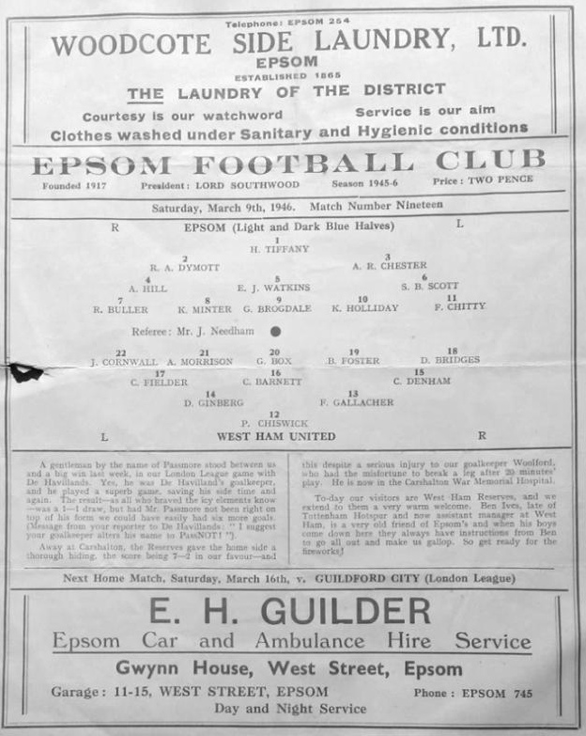
Wellington AFC dropped to Step Six for a while after this, but I’m pleased to say that they are back in Step Five this season and who knows, maybe we could be paired together again one day!

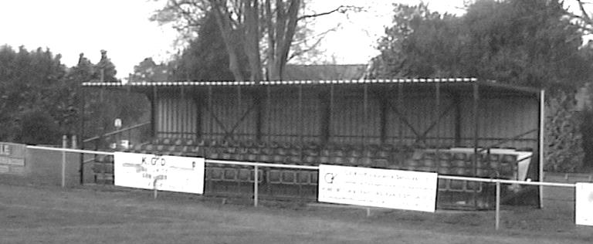
Wembley: Held over to next issue

West Ham ‘A’: Played 1 - W1 D0 L0 - F4 A3 - PPG - 3.00 - Perfect

Just after the end of World War Two we hosted a West Ham eleven at West Street in a friendly, winning 4-3 with goals from Ken Minter, Fred Chitty, Gordon Brogdale, and Ken Holliday. The programme pictured could well prove to be the most expensive in my collection as it would be extremely rare now.

Centre page for results

Centre page for results

Spelthorne Sports F.C. – History
Spelthorne Sports Club was founded in 1922 having purchased around 11 acres of land and has been providing sports for the local community ever since. We currently have 2 full sized football pitches and field 3 adult football teams and 2 Sunday teams along with a Youth Section covering Little Kickers through to the Mid-week Flood Lit Under 18’s, a total of 21 youth teams competing every Sunday in the Surrey Youth and Surrey Primary Leagues. The Youth Section was awarded the FA Charter Standard in March 2010 and the Annual Youth Tournament draws in many local teams since its inauguration in 2010.

In season 1998-99, Richard Ford and Micky Fisher took control of their 1st full season and saw them rise up the table. Both players were long serving Spelly players and had now moved into the management side. The team were led by Paul Fernadez with Paul Wilson in goal and Ian & Nick Croxford playing their 1st seasons with Spelly. We finished the season in 3rd spot and reached the final of the Russell Grant cup, where Sports did their usual thing of blowing it and lost to Northolt Saints 2-0 in the final at Uxbridge after they had beaten and drawn with them earlier in the season.

2001 was the first season of the new management team of Paul Martyn Jones (Trigger) and Ian Croxford. The team had the two scoring machines of James (OGGY) Hogg and Nick Croxford playing up front and with eventual player of the year Wes Coles in goal this was the most successful season for many a year. The team went from October through to April without losing a league game taking the league title in front of Willesden Constantine by 5 points, they were on the road to a league and cup double but were beat in the semi finals by Willesden with future professional footballer Enoch Showammi smashing home a 25 yard free kick.

In 2007, after many great years playing in the Middlesex league it was decided that a move to the Surrey League was required. The main driving force for this was that the league had expanded in such that game were all across London and for an amateur side an away trip to Bethnal Green was an all day event. The move to the Surrey Western was a change that was needed with pleasant drives through the country playing village teams rather than long hauls across London.

With the management now in the hands of Steve Flatman, a long time player and member of the club, the team saw a steady growth and this has to be credited to Steve. The first season saw Sports finish 7th with Horsley running away with the league. The next season saw some old faces come back into the team to support the young bucks with Oggy, Mike Jenkins and Ian Croxford coming back to support the team. The team finished second behind Ripley with Rob Smith finishing top league scorer with 21 and Lee Staples not far behind on 19. The season had its climax when Sports played their first final in many a year against Abbey Rangers at Cobham FC and with the team leading 1-0 at half time through a Jake Flatman goal they somehow grabbed defeat from the jaws of victory losing 2-1 with a spectacular 20 yard own goal from Aaron Stewart.

In 2009, Spelthorne Sports again moved leagues for the second time in three seasons as we progressed up through the FA pyramid system, this time to the Surrey Elite league. The

season started well but it was discovered that a (nameless) player had played with a ban from his now disbanded Sunday team. This resulted with Spelly being deducted all points that had been awarded while he was playing that season, 9 in total. Spelly finished the season 5th but if we had not lost the points we could possibly have finished third or even higher as the disappointment of losing these points was a bitter pill to swallow.

In the 2010-11 season Spelthorne Sports Football Club 1st Eleven Completed a league and cup double victory by winning the Surrey Elite Intermediate League and the Surrey intermediate Challenge cup. Their league success means they won promotion to the combined counties league which covers levels 9 and 10 of the English Football League System.

In 2013–14, the Spelly won the Middlesex FA Intermediate Cup, beating Middlesex County Premier side Cricklewood Wanderers 3–0 in the Final. On 16 April 2014, Spelthorne Sports were crowned Combined Counties Division One Champions with a 2–1 win away to Epsom Athletic. They lifted the trophy 3 days later following an emphatic 7–0 win at home to local rivals Staines Lammas. The Spelly also won the RPM Records Division One Challenge Cup against Staines Lammas at Windsor FC on 5 May 2014. A single second half Lee Staples goal was enough to make sure The Spelly lifted the trophy, winning the league and cup treble in the process.

The team went on a phenomenal 46 game unbeaten run in all competitions that season, beating teams in cup competitions from higher divisions such as Frimley Green, Staines Town (on pens), Walton Casuals, Wembley, and Epsom & Ewell (on pens). That unbeaten run finally came to an end on 7 May 2014 when they played Combined Counties Premier Division side Hanworth Villa in the Southern Combination Cup Final, losing 1–0. The game was played at home and marked the club's first ever game under the newly installed floodlights. The lads then suffered their second defeat of the season to the same opposition when the sides met again 3 days later in the Cherry Red Records Premier Challenge Cup Final, again losing 1–0.

The 2013–14 season was extremely successful for Spelthorne Sports. Winning two cup finals, and finishing runners-up in another two cup finals. However the biggest achievement by far was winning the league without losing a single game in the process. Winning 22, drawing 8, losing 0, scoring 92, and conceding 23.

Season 2014-2015 saw us in action in the Combined Counties Premier Division where we finished in a very respectful 6th position. We also experienced our first entry into the FA Vase. The promotion led to vast ground improvements yet again and this work continues to be done.

Season 2015/16 saw our first appearance in the FA CUP with a 2-1 home win against Stotfold. We then travelled to Cogenhoe only to lose 3-0. The season continued with a change of management back under the control of Steve Flatman with support from Paul Burgess and Mark Harper. Last season saw us off to a great start in the FA Cup beating CCL Winners Hartley Wintney 4-3, only to fall at the next hurdle losing 2-3 at home to Andover Town.

Having finished 8th and 9th in our first 2 seasons, this partnership continues into this, our 3rd season, where we are looking forward to seeing the continued development of football at ‘The Spelly’.

Match and Ball Sponsorships – 2017/18
Opponent | Date | Match Sponsor | Ball Sponsor
Banstead Athletic (FAC) | 06/08/17 | Club President - Stella Lamont
Chertsey Town | 15/08/17 | EEFC Management Committee
Redhill | 02/09/17 | Building Shop Ltd
Spelthorne Sports | 09/09/17 | In memory of Betty Dyke
Horley Town | 12/09/17 | Alex McKay (Senior)
Hanworth Villa | 23/09/17
North Greenford United | 28/10/17
Godalming Town | 11/11/17
Farnham Town | 14/11/17
Guildford City | 02/12/17
Abbey Rangers | 16/12/17
Walton & Hersham | 30/12/17
Balham | 20/01/18
Sutton Common Rovers | 03/02/18
CB Hounslow United | 13/02/18
Knaphill | 24/02/18
Camberley Town | 10/03/18
Bedfont Sports | 24/03/18
Colliers Wood United | 30/03/18
Banstead Athletic | 02/04/18 | Nathan Lambert – 10 years old today!
Westfield | 14/04/18
AFC Hayes | 28/04/18 | Club President - Stella Lamont
F.A. Vase 1st Round Proper |  | Unknown opponents
For League, League Cup and Surrey Senior Cup Matches:
Match sponsorship - £40.00 Match ball sponsorship - £25.00. Combined £55.00.
For F.A. Cup and F.A. Vase matches:
Match sponsorship - £50.00 Match ball sponsorship - £30.00. Combined £65.00.

Sponsorship includes: (x2 for match, x3 for match and ball)

Admission, programmes, hospitality and advertising and mascot for the day (if required).
If you are interested, just speak to a Committee Member, or drop me an email at: richard.c.lambert@gmail.com

We also thank our Kit Sponsors
G4 Group

First Eleven Appearances 2017/18 - (max 7)
Name | Debut | 2016/17 |  |  |  | Career Totals
 |  | App | Sub | Total | Goals | App | Sub | Total | Goals
AJAYI Tayo | 06/08/2017 | 3 | 2 | 5 | 1 | 3 | 2 | 5 | 1
BROOKS Jordan | 06/08/2017 | 3 | 0 | 3 | 0 | 3 | 0 | 3 | 0
CASTELL Cristian | 06/08/2017 | 2 | 1 | 3 | 0 | 2 | 1 | 3 | 0
DEWAR Ali | 29/10/2011 | 1 | 1 | 2 | 0 | 56 | 41 | 97 | 10
DYSON Ben | 12/08/2017 | 6 | 0 | 6 | 0 | 6 | 0 | 6 | 0
GRAHAM Bentley | 09/02/2016 | 1 | 0 | 1 | 0 | 18 | 1 | 19 | 3
GRIFFIN Reisse | 08/08/2015 | 6 | 0 | 6 | 0 | 79 | 13 | 92 | 6
HARLAND-GODDARD Tom | 06/08/2017 | 1 | 1 | 2 | 0 | 1 | 1 | 2 | 0
HARRIS Colin | 04/08/2012 | 6 | 0 | 6 | 0 | 31 | 0 | 31 | 0
HATFIELD Jamie | 11/11/2006 | 1 | 0 | 1 | 0 | 250 | 13 | 263 | 6
HAYWARD Ben | 07/03/2007 | 3 | 1 | 4 | 0 | 246 | 29 | 275 | 18
HENDRY Rob | 08/08/2015 | 3 | 0 | 3 | 2 | 71 | 22 | 93 | 25
HOUGH Kyle | 14/08/2007 | 4 | 2 | 6 | 3 | 337 | 21 | 358 | 204
JARMAN Mark | 08/08/2009 | 0 | 0 | 0 | 0 | 136 | 51 | 187 | 76
LAW Franky | 06/08/2017 | 3 | 0 | 3 | 0 | 3 | 0 | 3 | 0
LOFTUS-CHEEK Joe | 06/08/2017 | 6 | 0 | 6 | 2 | 6 | 0 | 6 | 2
MARVELL Dale | 15/01/2000 | 5 | 1 | 6 | 0 | 274 | 50 | 324 | 86
MCKAY Alex | 20/12/2008 | 0 | 0 | 0 | 0 | 131 | 37 | 168 | 12
MURPHY Scott | 20/01/2007 | 2 | 0 | 2 | 0 | 14 | 2 | 16 | 1
MYERS Antony | 23/12/2006 | 1 | 0 | 1 | 0 | 76 | 33 | 109 | 9
NWACHUKWU Jason | 01/10/2016 | 4 | 2 | 6 | 0 | 21 | 18 | 39 | 1
O'BRIEN Louis | 28/08/2017 | 1 | 2 | 3 | 0 | 1 | 2 | 3 | 0
ROBERTS Liam | 12/08/2017 | 2 | 2 | 4 | 0 | 2 | 2 | 4 | 0
ROBINSON Sam | 22/10/2011 | 0 | 0 | 0 | 0 | 21 | 5 | 26 | 5
ROSE Daniel | 25/10/2016 | 5 | 0 | 5 | 0 | 66 | 6 | 72 | 14
SMITH Andy | 25/08/2017 | 3 | 1 | 4 | 0 | 5 | 6 | 11 | 0
THOMPSON Ashley | 21/08/2017 | 1 | 0 | 1 | 0 | 1 | 0 | 1 | 0
THOMSON David | 02/09/2017 | 2 | 1 | 3 | 0 | 2 | 1 | 3 | 0
TURPIE Alistair | 31/03/2016 | 1 | 0 | 1 | 0 | 1 | 0 | 1 | 0
WHITE Sean | 02/08/2014 | 0 | 0 | 0 | 0 | 11 | 1 | 12 | 0

Combined Counties League Premier Division
Opponents All-time Records
inc Saturday 2nd Sept | P | W | D | L | F | A | PPG | GD | Best  Win | Worst  Loss
Godalming Town | 1 | 1 | 0 | 0 | 2 | 1 | 3.00 | +1 | 2-1 | X
Spelthorne Sports* | 7 | 5 | 2 | 0 | 15 | 6 | 2.43 | +9 | 6-2 | X
Horley Town | 30 | 21 | 5 | 4 | 67 | 31 | 2.27 | +36 | 6-0 | 1-3
Abbey Rangers | 4 | 3 | 0 | 1 | 11 | 4 | 2.25 | +7 | 7-1 | 2-3
Sutton Common Rovers | 13 | 9 | 2 | 2 | 30 | 19 | 2.23 | +11 | 4-0 | 0-5
Bedfont Sports | 11 | 7 | 2 | 2 | 21 | 12 | 2.09 | +9 | 5-1 | 0-4
Banstead Athletic | 38 | 23 | 7 | 8 | 62 | 38 | 2.00 | +24 | 5-0 | 0-4
Knaphill | 8 | 5 | 1 | 2 | 17 | 9 | 2.00 | +8 | 4-0 | 1-2
Guildford City | 18 | 11 | 1 | 6 | 35 | 22 | 1.89 | +13 | 5-1 | 1-5
Westfield | 21 | 12 | 3 | 6 | 43 | 36 | 1.86 | +7 | 6-1 | 0-4
Colliers Wood United | 24 | 14 | 2 | 8 | 47 | 39 | 1.83 | +8 | 4-0 | 0-5
Farnham Town | 15 | 8 | 3 | 4 | 27 | 25 | 1.80 | +2 | 3-1 | 1-4
Hanworth Villa | 17 | 8 | 4 | 5 | 38 | 27 | 1.65 | +11 | 5-0 | 1-4
Walton & Hersham | 52 | 25 | 11 | 16 | 105 | 99 | 1.65 | +6 | 8-0 | 1-9
Camberley Town* | 90 | 38 | 22 | 29 | 158 | 125 | 1.51 | +33 | 9-1 | 0-4
Redhill | 34 | 14 | 2 | 18 | 63 | 74 | 1.29 | -11 | 7-2 | 2-8
Chertsey Town | 50 | 19 | 5 | 26 | 77 | 94 | 1.24 | -17 | 3-0 | 0-7
North Greenford United | 12 | 4 | 2 | 6 | 18 | 22 | 1.16 | -4 | 3-0 | 1-4
AFC Hayes | 10 | 2 | 3 | 5 | 18 | 18 | 0.90 | 0 | 7-0 | 0-3
CB Hounslow United | 4 | 1 | 0 | 3 | 6 | 11 | 0.75 | -5 | 2-0 | 1-5
Balham | - | - | - | - | - | - | - | - | - | -
* includes one abandoned match v Camberley and one loss on penalties v Spelthorne

Salts Super Six Predictor
The Salts Super Six Predictor is live again today and the tickets are on sale at today’s game to the left of the gate. The matches are to be played at some point today.

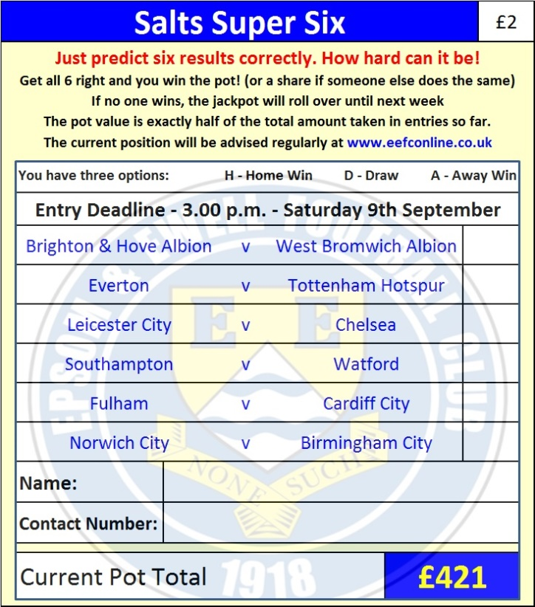
The jackpot is now up to £421 which if won would represent the largest individual prize so far and who knows how much higher it could rise!

The competition is easy to play! To win, you simply need to predict the results of six matches correctly from the three options, fill in the form and make sure it is back with our seller before the deadline on the ticket. The latest fixtures are shown below.

If you are a club regular, you just need to place your name on the sheet, although if you aren’t, then we’ll need a contact number from you too. We will announce any winners on the website within three working days, so don’t worry, we won’t miss you!

Please note that if there is more than one winner, the prize pot would be shared between the winners. All you need to do now is have a go, as many times as you like!

Good luck!

Combined Counties League – Premier Division
Saturday, 9th September 2017 - Kick-off 3.00 p.m.
Epsom and Ewell  (Royal Blue & White hoops) | V |  | Spelthorne Sports  (All Red)
Squad | NUMBERS |  | Squad
Colin Harris |  |  | Brendan Hazlett
Reisse Griffin |  |  | Luke Richards
Ben Dyson |  |  | Sam Rees
David Thomson |  |  | Joe Dyett
Scott Murphy |  |  | Graham Edwards
Louis O’Brien |  |  | Josh Remedios
Ben Hayward |  |  | Jake Flatman
© Sam Robinson |  |  | Lewis Flatman
Kyle Hough |  |  | Matthew Weston
Joe Loftus-Cheek |  |  | Lee Staples
Rob Hendry |  |  | Ben Thorne
Dale Marvell |  |  | Luke Bersey
Daniel Rose |  |  | Calum MacKay
Antony ‘Freddy’ Myers |  |  | Ben Ewing
Jason Nwachukwu |  |  | Callum Beachamp
Jordan Brooks |  |  | Quaseem Sotonwa
Sean White
Liam Roberts
Tayo Ajayi
Ali Dewar
Tom Harland-Goddard
Alistair Turpie
Ashley Thompson
Andy Smith
Glyn Mandeville | MANAGER |  | Steve Flatman
Matt Smith | ASSISTANT |  | Paul Burgess / Mark Harper
Alex McKay / Jimmy Hendry | COACHES / PHYSIO |  | Andy Tomkins
REFEREE: L.Pinto Nunes
ASSISTANTS: M.Kelly, B.Browne
Today’s Match and Match Ball are kindly sponsored:
in memory of Betty Dyke

OUR NEXT VISITORS TO HIGH ROAD
Horley Town
Cherry Red Combined Counties League – Premier Division
Tuesday 12th September 2017 – 7.45 p.m.

